**Observation of robust magnetic order in monolayer NiPS3**

Lili Hu1,2†, Hao-Xin Wang4†, Yuzhong Chen1, Kang Xu2, Ming-Rui Li3, Haiyun Liu1, Peng Gu1, Yubin Wang2, Mengdi Zhang1, Hong Yao4,2, Qihua Xiong1,2,5,6*

1 *Beijing Academy of Quantum Information Sciences, Beijing 100193, P.R. China*

2 *State Key Laboratory of Low-Dimensional Quantum Physics and Department of Physics, Tsinghua University, Beijing 100084, P.R. China*

3 *Institute for Advanced Study, Tsinghua University, Beijing 100084, China*

5 *Frontier Science Center for Quantum Information, Beijing, P.R. China*

6 *Collaborative Innovation Center of Quantum Matter, Beijing, P.R. China*

*To whom correspondence should be addressed. Emails:* [qihua_xiong@mail.tsinghua.edu.cn](mailto:qihua_xiong@mail.tsinghua.edu.cn)，and [yaohong@tsinghua.edu.cn](mailto:yaohong@tsinghua.edu.cn)

† These authors contributed equally to this work.

**Abstract**

Monolayer ferromagnet and antiferromagnet of XY-type compose a pivotal part of the two-dimensional magnetism, which has become one of the new frontiers in two-dimensional materials. Because of the zero net magnetic moment and strong spin fluctuation, investigations and confirmations of monolayer XY-type antiferromagnet often confront ambiguity and intriguing issues. As an important XY-type antiferromagnet and Berezinskii-Kosterlitz-Thouless (BKT) transition candidate, whether monolayer NiPS3 exhibits magnetic order at low temperature remains elusive. Herein we have investigated the helicity-resolved Raman and ultrafast spectroscopy of NiPS3 from bulk to monolayer samples. By analyzing the intrinsic two-magnon properties and ultrafast transient absorptions, we find that monolayer NiPS3 is magnetically ordered at low temperatures with a BKT-transition at *T*BKT 140 K. We have also performed large-scale density-matrix-renormalization-group calculations to verify the zigzag-AFM magnetic order in the ground state and Monte-Carlo simulation to obtain the BKT-transition temperature in monolayer NiPS3. The theoretically obtained transition temperature *T*BKT of monolayer NiPS3 agrees well with our experimental data. Combining our experimental and theoretical results, we have thus unambiguously established that monolayer NiPS3 is an ordered XY-type antiferromagnet with a relatively high-temperature BKT-transition, providing an important platform for investigating complex couplings and topological excitations in two-dimensional magnetic materials.

Two-dimensional materials have provided an important platform for fundamental physics and unprecedented device functionalities, driven by various elementary excitations in the two-dimensional (2D) limit resulted from peculiar confinement behaviors and strong interactions1. Recently, considerable progress has been made in the emergent two-dimensional magnetic materials2,3. According to the Mermin-Wagner theorem, long-range ferromagnetism (FM) and antiferromagnetism (AFM) breaking the continuous global symmetry in 2D isotropic Heisenberg model are expected to be forbidden at finite temperatures4. However, the single-ion anisotropy in magnetic interactions caused by spin-orbit coupling and the interaction between adjacent layers can facilitate the realization of two-dimensional long-range magnetic orders. A variety of two-dimensional magnetic materials have been experimentally verified recently, most of which are of Ising type5,6 or Heisenberg type7,8. In addition, it is theoretically proved that there may exist a special topological BKT-transition at finite temperatures in an XY-like two-dimensional system, hallmarked by the transition from bound vortice-antivortice pairs into free vortices9. The BKT-phase transition is found to have a tight correlation with superfluidity10, Bose-Einstein condensation11, and superconductivity12. Only in material systems fitted with XY (or XXZ-model with weak interlayer interaction), BKT-transition is possible to be observed experimentally.

Recently, important progress in many-body exciton13, magnon-phonon coupling14, and magnon-based device15 has been made in the field of 2D antiferromagnetic materials. The intralayer antiferromagnetic *M*P*X*3 (*M* = Fe, Ni, Mn, and *X* = S, Se) family has attracted increasing attention due to their (quasi)2D antiferromagnetism, rich spin dimensionalities, strong coupling between multi-degrees of freedom, and potential applications in quantum information technology16,17. With varying transition metal *M* atoms among Fe, Ni, and Mn, the magnetism in *M*P*X*3 behaves as Ising-type (FePS3), XY-type (NiPS3), and Heisenberg-type (MnPS3). While the bulk *M*P*X*3 exhibit the *C*2*h* point group symmetry, the point group of the monolayer is *D*3*d*. NiPS3 inherits the lattice structure of *M*P*X*3 family, where the intralayer Ni2+ ions form a honeycomb lattice18,19, as schematically shown in Fig. 1a. The Ni2+ ions with the same spin direction form the zigzag FM chains parallel to the *a*-axis and the FM chains are coupled in an AFM manner. At about 155 K, NiPS3 undergoes a phase transition from zigzag-AFM to paramagnetism (PM). The temperature dependence of phonon splitting and linear dichroism suggested that zigzag-AFM exists only within the thickness ranging from bulk to bilayer, with the monolayer found magnetically disordered due to enhanced spin fluctuation20,21. Note that the phonon splitting due to symmetry lowering from *D*3d to *C*2h by zigzag-AFM order has been observed in monolayer CoPS3, a sister compound of monolayer NiPS3, making the magnetic phase of monolayer NiPS3 more intriguing22. Meanwhile, some theoretical studies have suggested that there exists a magnetic order in the monolayer NiPS323,24. Even it is highly suspected that BKT-transition exists in monolayer NiPS3, no phase transition has been ever detected experimentally till now. Whether there is a magnetic order in the monolayer NiPS3 and how to detect this ordering has become an urgent problem in the field of two-dimensional magnetic materials. In addition, NiPS3 has been regarded as a platform to study the intertwining physical phenomenon between spin and other degrees of freedom, which has not been fully understood21. Especially a spin-coupled coherent exciton has been observed in NiPS3 system which is very unusual for magnetic materials13,21,25. To clarify the physical mechanism underlying the spin-coupled behaviors of charge, lattice, exciton, and magnon in two-dimensional limit towards rational manipulating these couplings, the experimental determination of magnetic order for NiPS3 monolayer is highly demanded. Here we report the experimental observation of robust magnetic order in monolayer NiPS3. This conclusion is supported by results of helicity-resolved Raman and ultrafast spectroscopy, as well as by theoretical calculations. All our experimental observations and theoretical calculations support the magnetic phase transition at ~140 K for monolayer NiPS3.

Figure 1a shows the schematic lattice structure and the magnetic order of a single layer NiPS3 in the bulk systems. The upper panel of Fig. 1b shows the optical images of monolayer and bilayer NiPS3 on Si/SiO2 substrates, prepared by mechanical exfoliation methods (see details in Methods), for the purpose of helicity-resolved Raman spectroscopy measurements26. The three lower panels of Fig. 1b are the optical images of monolayer, bilayer, and thin bulk samples on transparent substrates (SiO2 for monolayer, and sapphire for bilayer and thin bulk) used for the ultrafast spectroscopy experiments. The AFM cross section traces are presented in Fig. 1b to characterize the sample thickness. The helicity-resolved Raman spectra of single crystal and monolayer NiPS3 at 30 K are shown in Fig. 1c and 1d, with the corresponding polarization configurations annotated at the right top corner of each panel, in which XX (XY) represents co- (cross-) linear polarization and σ+σ+ (σ+σ-) represent co- (cross-) circular polarization configurations, respectively. The main phonon peaks are assigned in spectra under σ+σ- and σ+σ+ polarizations to cover all the phonon peaks observed. As can be seen from Fig. 1c and 1d, according to the polarization dependence observed, all the phonon peaks can be understood based on *D*3d symmetry (the Raman tensor analysis of the *D*3d point group can be found in Supporting Information), which is in good agreement with previous literatures, implying a weak interlayer interaction in the NiPS3 system27. With the *D*3d point group, the Raman active modes can be divided into *A*g (out-of-plane vibration) and *E*g (in-plane vibration) modes28. When considering the weak interlayer interaction or symmetry lowering by zigzag-AFM order, the *E*g modes should split into *A* and *B* modes, resulting in the frequency splitting of spin-order sensitive $E_{g}^{1}$ mode under different linear polarizations (XX and XY) as denoted by the dashed lines in Fig. 1c. Note that the frequency splitting of specific $E_{g}^{1}$ phonon peak at around 175 cm-1 was utilized as a criterion to determine the existence of zigzag-AFM order in NiPS3 in previous report20. Other than the narrow phonon peaks, there is a broad continuum scattering in Raman spectra as shown in Fig. 1c and 1d, which is identified to be two-magnon scattering (denoted as 2M mode)20,29. The 2M signal is highlighted by a red shadow, resulted from a composite lineshape analysis. It can be seen from Fig. 1c and 1d that the 2M band only appears in XX, XY, and σ+σ- polarizations, while the scattering intensity under the σ+σ- is about twice of that under the XY polarization, indicating that the 2M modes belong to the *E*g representation of *D*3d point group (see Supporting Information for detailed analysis).

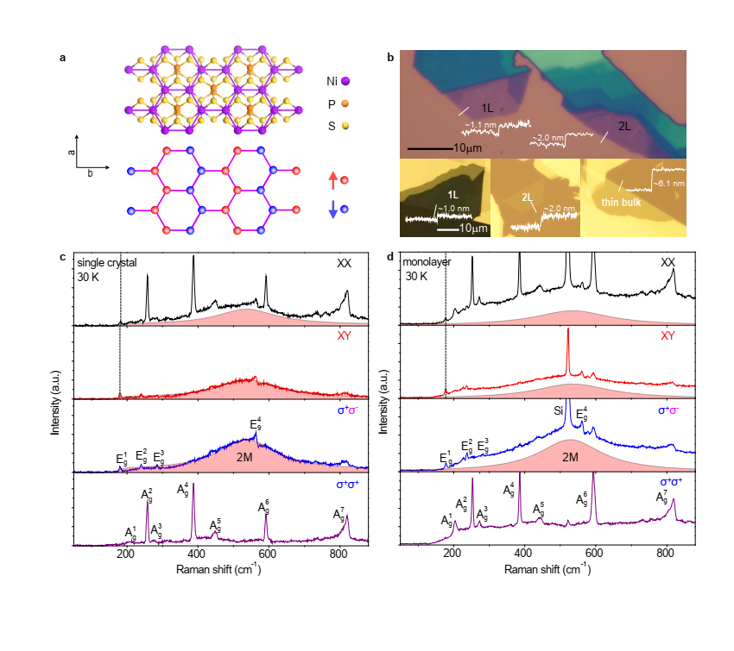

**Fig. 1 | The NiPS3 samples and helicity resolved Raman spectra.** **a,** Lattice and magnetic structure of a single-layer. **b,** Optical photographs of monolayer and bilayer NiPS3 for helicity-resolved Raman spectroscopy and monolayer, bilayer and thin bulk NiPS3 for ultrafast spectroscopy. The height of the samples is indicated by the AFM cross section traces. **c and d,** Helicity-resolved Raman spectra of single crystal and monolayer at 30 K.



**Fig. 2 | Temperature-dependent Raman spectra of single crystal, bilayer, monolayer NiPS3 at σ+σ- polarization. a,** **b, and c,** Temperature-dependent Raman spectra of single crystal, monolayer, and bilayer NiPS3. **d,** **e, and f,** Colormaps of normalized Raman spectra at σ+σ- polarization for single crystal, monolayer, and bilayer NiPS3. **g-i**, Temperature dependence of frequency (ω), FWHM, *dω*/*d*T, and *d*FWHM/*d*T for single crystal, monolayer and bilayer at σ+σ- polarization.

Because the 2M band has overwhelming intensity and a better signal-to-noise ratio under the σ+σ- polarization, the 2M properties are mainly analyzed from Raman spectra at σ+σ- polarization. Temperature-dependent Raman spectra of single crystals, monolayer, and bilayer (offset vertically for clarity) are shown in Fig. 2a, 2b, and 2c respectively. As the temperature increases from 30 K to 290 K, the 2M band broadens and redshifts remarkably. Although the intensity decreases as temperature increases, the 2M band is still prominent even at 290 K. Across all the temperatures, the intensity at σ+σ- polarization keeps almost twice of that at XY polarization, obeying well to the *D*3d symmetry thus suggesting that in the whole temperature range the quasi-2D property of 2M can be maintained (see Supporting Information). To further elaborate the temperature evolution of 2M bands, we normalize the Raman spectra to the maximum of 2M band ($I_{2M}^{max}$) under σ+σ- polarization, and plot the normalized Raman spectra into colormap graphs, as shown in Fig. 2d, 2e and 2f. From the colormaps, we can see that the frequency (ω) and full width at half-maximum (FWHM) of 2M bands all show abrupt changes at *T* ≈ 150 K for single crystal, monolayer, and bilayer. The values of ω and FWHM can be obtained by fitting the 2M band with Lorentzian lineshape. It is well known that the Néel temperature *T*N ≈ 150 K for bulk NiPS3 corresponds to AFM-PM phase transition21,23. Thus the 2M properties indicate a magnetic phase transition for the NiPS3 system of different thicknesses at about 150 K. We plot ω and FWHM of 2M band with temperatures in Fig. 2g-2i to quantitatively analyze the temperature-dependence of 2M properties, especially the remarkable change at magnetic phase transition temperature. The ω and FWHM are shown by the open squares and open diamonds in Fig. 2g-2i. We also obtain the first-order derivatives of ω and FWHM versus temperature for single crystal, monolayer, and bilayer as shown by the red and blue balls in Fig. 2g-2i, while the red and blue curves are guides for the eyes. The emergence of singularity points of *dω*/*d*T and *d*FWHM/*d*T at ~140 K for monolayer strongly suggest that the monolayer NiPS3 sample has robust magnetic ordering at low temperature.

We then investigate the transient absorption spectra of the monolayer, bilayer, and thin bulk NiPS3 samples at variable temperatures, pumped by a 385 nm femtosecond laser pulse (see Methods for details). Figure 3a shows the steady-state absorption spectra of monolayer and thin bulk samples at 60 K and 240 K, respectively. The centers of the absorption peaks are about 570 nm and 560 nm for thin bulk and monolayer samples respectively, with a slight redshift with the increase of temperature. The wavelength chosen for analyzing the magnitude of the time-resolved ΔT/T is 532 nm to keep consistent with the Raman excitation wavelength (for other probe wavelengths, see Supporting Information). Figure 3b shows the temperature-dependent ultrafast dynamics of monolayer NiPS3 from 60 K to 240 K, offset vertically for clarity. The colormap by plotting ΔT/T versus the time delays and the temperatures (60-240 K) are displayed in Fig. 3c-3e for monolayer, bilayer, and thin bulk samples respectively. As shown in Fig. 3c and 3d, for the monolayer and bilayer samples, the magnitude of ΔT/T is decreasing with the increase of temperatures generally, but there is a local maximum near 150 K 30,31, which indicates that the phase transitions of monolayer and bilayer NiPS3 occurring at about 150 K. For the thin bulk sample as shown in Fig. 3e, the change of the color scale in 120 K -170 K is less sensitive to indicate the phase transition. We further extract the (ΔT/T)max of monolayer, bilayer, and thin bulk samples to plot versus the temperature, as shown in Fig. 3f, vertically offset for clarity (the offset values are 5×10-3 for bilayer and 1×10-2 for monolayer). It can be seen that a plateau-like region of (ΔT/T)max appears at about 150 K for all samples, signifying the magnetic phase transition for monolayer, bilayer, and thin bulk NiPS3, in accordance with the results of helicity-resolved Raman spectroscopy. The transition temperatures extracted from Fig. 3f are 160 K for bulk, 150 K for bilayer and 140 K for monolayer. Since NiPS3 is of XY-type, with the thinning of the layers, it is likely that the phase transition changes from AFM-PM transition for the bulk to BKT-transition for the monolayer.

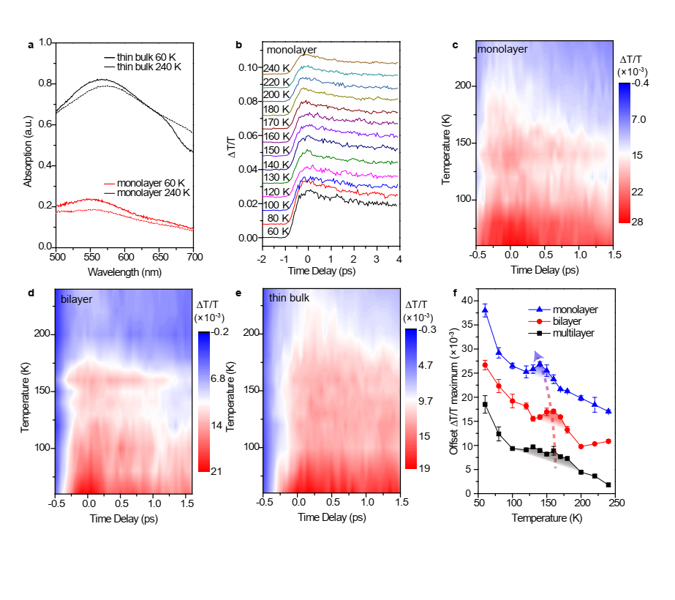

**Fig. 3 | Ultrafast spectroscopy investigation of NiPS3. a,** The steady state absorption spectra of monolayer and thin bulk at 60 K and 240 K. **b,** The temperature-dependent ultrafast dynamics of monolayer NiPS3. **c, d, and e,** The colormap of time-resolved ΔT/T for monolayer, bilayer, and thin bulk NiPS3. **f,** The temperature dependent of (ΔT/T)max for monolayer, bilayer, and thin bulk.



**Fig. 4 | Magnetic ground state and BKT transitions in monolayer NiPS3.** **a,** in-plane spin correlations. **b,** sublattice spin structure factor for the ground state of the *J*1-*J*2-*J*3-*D* model, calculated by DMRG. **c-e,** Temperature dependence of the Monte-Carlo-computed spin stiffness, AF magnetization, and specific heat at different linear size $L$.

To gain insight into the low-temperature magnetic phase, and the corresponding phase transition, we further perform theoretical calculations for the monolayer to determine the ground state at zero temperature and obtain the phase transition temperature. We consider a minimal effective spin-1 model on the honeycomb lattice including dominating spin-exchange coupling and single-ion anisotropy (SIA) which reads

$$H=J_{1}\sum_{⟨i, j⟩}{S_{i}⋅S_{j}}+J_{2}\sum_{⟨⟨i, j⟩⟩}{S_{i}⋅S_{j}}+J_{3}\sum_{⟨⟨⟨i, j⟩⟩⟩}{S_{i}⋅S_{j}}+D\sum_{i}{{\left(S_{i}^{z}\right)}^{2} },$$

where $\left\langle i, j\right\rangle$, $\left\langle \left\langle i, j\right\rangle \right\rangle$ and $⟨⟨⟨i, j⟩⟩⟩$ represent the nearest, the next-nearest, and the third-nearest neighbor (NN, NNN, and TNN) sites $i$ and $j$, respectively. We adopt the following set of parameters according to DFT calculations24: Here, anisotropy terms except single ion anisotropy (SIA) $D$ are neglected after carefully considering the crystal field splitting of the Ni2+ ion and the crystal symmetry. Specifically, $D$ is induced by spin-orbit-driven intermixing of the singlet ground state $3A_{2g}$ and the excited state 330,31, while other SIA terms are forbidden by the $D_{3d}$ symmetry. The secondary anisotropy, the Dzyaloshinskii-Moriya exchange interaction, is forbidden by spin inversion symmetry between NN and TNN sites and is estimated to be smaller than $0.01 meV$ between NNN sites32.

To investigate the low-temperature magnetic order of the *J*1-*J*2-*J*3-*D* model, we implement a large-scale density matrix renormalization group (DMRG) calculation to find the ground state properties. We show the spin order in the ground state on a so-called XC6-cylinder in Fig. 4a and 4b. The length of the red and blue arrows in Fig. 4a is proportional to the amplitude of the spin-correlation $C\left(r,r_{0}\right)=⟨S_{r_{0}}^{x}S_{r}^{x}+S_{r_{0}}^{y}S_{r}^{y}⟩$. Referred from a central site at $r_{0}$, which is marked as a purple cross in Fig. 4a, the in-plane spin correlation $C\left(r,r_{0}\right)$ shows a long-range zig-zag antiferromagnetic order along the ruing of the cylinder ($x$-direction), indicating an easy-plane spin orientation, *i.e.* monolayer NiPS3 can be effectively described by XY-type spin model. Figure 4b shows the sublattice spin structure factor $S_{AA}\left(q\right)=\frac{1}{L_{1}L_{2}}\sum_{i∈A, j∈A}{\left\langle S_{i}⋅S_{j}\right\rangle e^{i q⋅(r_{i}-r_{j})}}$. The sole peak around $M$ point as shown in Fig. 4b confirms the zig-zag order at zero temperature and gives the value of the magnetic moment $m_{s}=0.73$. In addition, we also explore the magnetic order on a different geometry YC6-cylinder which exhibits the same zig-zag order (see details in Supporting Information).

A 2D model with continuous U(1) spin rotational symmetry, according to the Mermin-Wagner theorem, forbids long-range magnetic order at finite temperature but allows for quasi-long-range order. To justify the possibility of the BKT phase transition, we simulate the *J*1-*J*2-*J*3-*D* model of classical spins based on the Monte-Carlo method and determine the phase transition temperature by spin stiffness. The geometry in the simulation is torus with site number, where is the linear size. The BKT transition is determined by the temperature that provides an abrupt vanishing of the spin stiffness. Figure 4c shows the results of stiffness for the different system sizes. Following the standard procedure of the finite-size extrapolation (see methods), the transition temperature of monolayer NiPS3 is estimated to be around 141 K, as shown in the inset to Fig. 4c, in excellent agreement with the experimental result of 140 K. The calculated in-plane AF magnetization and specific heat data plotted in Fig. 4d and 4e also support this transition temperature. We also find that the transition temperature is not sensitive to the magnitude of the SIA (see details in Supporting Information).

**Discussion**

As we have discussed above, the topological BKT phase transition offers an interpretation of the magnetic order in monolayer NiPS3, namely, the quasi-long-range order formed below *T*BKT. Such type of transition has previously been indicated in bulk NiPS3 by measuring and fitting the frequency of light-induced magnon by *f* ∝ (*T*N-*T*)*β* , with *β* = 0.23 ± 0.0131, in good accordance with XY-type model. However, the previous experiments claim no magnetic order in monolayer NiPS3 based on the absence of the frequency splitting between phonon peak under XX and XY polarizations. Here, we propose two possible explanations that may resolve this contradiction. The first one is considering ubiquitous magnetic domains24. The three kinds of domains with different zigzag-AFM directions related by $C_{3}$ rotational symmetry appearing in the monolayer will average the linear dichroism effect. Thus, in the presence of magnetic domains the frequency splitting cannot be used to indicate the magnetic order in monolayer NiPS3. The second possible explanation is considering high-order spin interactions. Such interactions will induce higher-order coupling terms between the three zigzag orders in the Landau-Ginzburg free energy and lead to a candidate new phase where the three zigzag orders coexist, similar to the 3-Q pair-density-wave phase33. The 3-zigzag ordered phase preserves the $C_{3}$ rotational symmetry thus the zigzag-order sensitive frequency splitting and linear dichroism vanishes. On the other hand, strong two-magnon scattering is one of the characteristic excitations in AFM materials34. The critical behavior of 2M frequency at *T*N has been reported for antiferromagnets such as RbMnF3 and FeF235, due to the qualitative change of spin-correlation at the magnetic phase transition temperature. Here in (monolayer) NiPS3 systems, the (quasi-)long-range spin correlation at *T* < *T*N (*T*BKT) is replaced by the short-range spin fluctuation at *T* ≥ *T*N (*T*BKT), leading to the redshift of 2M frequency at *T*N (*T*BKT), as observed in Fig. 2. In addition, the linewidth of 2M band can also experience a sudden change nearing the temperature that spin-wave gap closes, *i.e.* *T*N, or the temperature that bound vortice-antivortice pairs forms, *i.e.* *T*BKT. With temperature increases, the enhancement of the thermal excitation and the spin fluctuation will provide more relaxation pathways to the 2M excitation at *T* ≥ *T*N (*T*BKT), so the linewidth of 2M band can also increase abruptly at *T*N (*T*BKT)36. As a result, the temperature dependence of intrinsic properties of 2M mode in NiPS3 manifests the magnetic phase transition effectively, *i.e.* both AFM-PM transition and BKT-transition. In our work, the temperature-dependent frequency and FWHM of 2M band confirm the existence of magnetic order for monolayer. Moreover, our analysis also unambiguously shows that the 2M Raman scattering, which mainly relies on the spin-correlation, is a robust tool to study magnetic ordering in two-dimensional magnetism. Since monolayer NiPS3 is of XY-type without interlayer interaction, it should be the BKT-transition that happens in it.

In pump-probe transient spectroscopy, the pump laser is used to excite transient carriers, which introduces a transient dielectric response of the sample, while the probe laser detects change of the reflection or transmission. Since a phase transition can usually accompany the change of dielectric functions of materials, the time-resolved differential reflection (ΔR/R) or transmission (ΔT/T) can be used to detect the phase transition of materials37,38. Usually the ΔR/R or ΔT/T is proportional to the excited carrier (or photoexcited quasiparticles) density. Since there is strong spin-charge coupling and spin-phonon coupling in NiPS320,39, the magnetic phase transition can change the dielectric function and thus the differential transmission ΔT/T can reflect the magnetic phase transition. When the NiPS3 thickness changes from bulk to bilayer, it is therefore reasonable to assume that the pump induced excitation of a quasiparticle from the spin ground state to above the spin-wave gap will contribute to the differential ΔT/T. As the temperature increases to near *T*N, the spin-wave gap decreases and the high-energy phonons produced by carrier relaxation can excite the spin from the ground state to above the spin-wave gap, bringing an additional increase of ΔT/T at a temperature near *T*N. This may be one of the important reasons why we can observe the magnetic phase transition in NiPS3 samples from bulk to bilayer by ultrafast spectroscopy. In addition, in NiPS3 monolayer of XY-type the ultrafast dynamics can also be used to identify the quasi-long-range magnetic order. A recent theoretical investigation has pointed out that after a possible BKT-phase transition in monolayer NiPS3, the breaking of bound vortice-antivortice pairs into free vortices can contribute to the change of dielectric function across *T*BKT40, which can qualitatively explain the peak of (ΔT/T)max that we observed in monolayer NiPS3. Combining the results of 2M properties, the temperature dependent (ΔT/T)max and the theoretical calculations, we can conclude that robust quasi-long-range magnetic order exist even in monolayer NiPS3, whose magnetic phase transition should be of BKT-type.

**Conclusion**

In summary, by studying the helicity-resolved Raman spectroscopy and the ultrafast spectroscopy with various thickness down to monolayer, we have unambiguously identified magnetic order in NiPS3 from bulk to monolayer. By examining the 2M properties and transient absorptions, we obtained the phase transition temperatures of NiPS3 samples with different thicknesses, which are about 160 K for bulk, 150 K for bilayer and 140 K for monolayer, indicating AFM-PM phase transition in bulk and BKT-transition in monolayer. Indeed, theoretical simulations show that monolayer NiPS3 has zigzag-AFM ordered ground state at zero temperature and BKT-transition at finite temperatures. Therefore, our investigations convincingly settle that the monolayer NiPS3 is a 2D XY-type antiferromagnet, providing a promising platform for topological excitations and magnetism engineering.

**References**

1 Butler, S. Z. *et al.* Progress, challenges, and opportunities in two-dimensional materials beyond graphene. *ACS Nano* **7**, 2898-2926 (2013).

2 Gong, C. & Zhang, X. Two-dimensional magnetic crystals and emergent heterostructure devices. *Science* **363**, eaav4450 (2019).

3 Gibertini, M., Koperski, M., Morpurgo, A. F. & Novoselov, K. S. Magnetic 2D materials and heterostructures. *Nature Nanotechnology* **14**, 408-419 (2019).

4 Mermin, N. D. & Wagner, H. Absence of ferromagnetism or antiferromagnetism in one-or two-dimensional isotropic Heisenberg models. *Physical Review Letters* **17**, 1133 (1966).

5 Huang, B. *et al.* Layer-dependent ferromagnetism in a van der Waals crystal down to the monolayer limit. *Nature* **546**, 270-273 (2017).

6 Wang, X. *et al.* Raman spectroscopy of atomically thin two-dimensional magnetic iron phosphorus trisulfide (FePS3) crystals. *2D Materials* **3**, 031009 (2016).

7 Gong, C. *et al.* Discovery of intrinsic ferromagnetism in two-dimensional van der Waals crystals. *Nature* **546**, 265-269 (2017).

8 Du, K.-z. *et al.* Weak van der Waals stacking, wide-range band gap, and Raman study on ultrathin layers of metal phosphorus trichalcogenides. *ACS Nano* **10**, 1738-1743 (2016).

9 Kosterlitz, J. M. & Thouless, D. J. Ordering, metastability and phase transitions in two-dimensional systems. *Journal of Physics C: Solid State Physics* **6**, 1181 (1973).

10 Clade, P., Ryu, C., Ramanathan, A., Helmerson, K. & Phillips, W. D. Observation of a 2D Bose gas: from thermal to quasicondensate to superfluid. *Physical Review Letters* **102**, 170401 (2009).

11 Simula, T. P. & Blakie, P. Thermal activation of vortex-antivortex pairs in quasi-two-dimensional Bose-Einstein condensates. *Physical Review Letters* **96**, 020404 (2006).

12 Blatter, G., Feigel'man, M. V., Geshkenbein, V. B., Larkin, A. I. & Vinokur, V. M. Vortices in high-temperature superconductors. *Reviews of Modern Physics* **66**, 1125 (1994).

13 Kang, S. *et al.* Coherent many-body exciton in van der Waals antiferromagnet NiPS3. *Nature* **583**, 785-789 (2020).

14 Liu, S. *et al.* Direct observation of magnon-phonon strong coupling in two-dimensional antiferromagnet at high magnetic fields. *Physical Review Letters* **127**, 097401 (2021).

15 Chen, G. *et al.* Electrically switchable van der Waals magnon valves. *Nature Communications* **12**, 1-5 (2021).

16 Jiang, X. *et al.* Recent progress on 2D magnets: Fundamental mechanism, structural design and modification. *Applied Physics Reviews* **8**, 031305 (2021).

17 Rahman, S., Torres, J. F., Khan, A. R. & Lu, Y. Recent developments in van der Waals antiferromagnetic 2D materials: synthesis, characterization, and device implementation. *ACS Nano* **15**, 17175–17213 (2021).

18 Susner, M. A., Chyasnavichyus, M., McGuire, M. A., Ganesh, P. & Maksymovych, P. Metal thio‐and selenophosphates as multifunctional van der Waals layered materials. *Advanced Materials* **29**, 1602852 (2017).

19 Bernasconi, M. *et al.* Lattice dynamics of layered MPX3 (M= Mn, Fe, Ni, Zn; X= S, Se) compounds. *Physical Review B* **38**, 12089 (1988).

20 Kim, K. *et al.* Suppression of magnetic ordering in XXZ-type antiferromagnetic monolayer NiPS3. *Nature Communications* **10**, 1-9 (2019).

21 Hwangbo, K. *et al.* Highly anisotropic excitons and multiple phonon bound states in a van der Waals antiferromagnetic insulator. *Nature Nanotechnology* **16**, 655-660 (2021).

22 Liu, Q. *et al.* Magnetic order in XY-type antiferromagnetic monolayer CoPS3 revealed by Raman spectroscopy. *Physical Review B* **103**, 235411 (2021).

23 Sivadas, N., Daniels, M. W., Swendsen, R. H., Okamoto, S. & Xiao, D. Magnetic ground state of semiconducting transition-metal trichalcogenide monolayers. *Physical Review B* **91**, 235425 (2015).

24 Kim, T. Y. & Park, C.-H. Magnetic anisotropy and magnetic ordering of transition-metal phosphorus trisulfides. *Nano Letters* **21**, 10114–10121 (2021).

25 Wang, X. *et al.* Spin-induced linear polarization of photoluminescence in antiferromagnetic van der Waals crystals. *Nature Materials* **20**, 964-970 (2021).

26 Chen, S.-Y., Zheng, C., Fuhrer, M. S. & Yan, J. Helicity-resolved Raman scattering of MoS2, MoSe2, WS2, and WSe2 atomic layers. *Nano Letters* **15**, 2526-2532 (2015).

27 Lançon, D., Ewings, R., Guidi, T., Formisano, F. & Wildes, A. Magnetic exchange parameters and anisotropy of the quasi-two-dimensional antiferromagnet NiPS3. *Physical Review B* **98**, 134414 (2018).

28 Kuo, C.-T. *et al.* Exfoliation and Raman spectroscopic fingerprint of few-layer NiPS3 van der Waals crystals. *Scientific Reports* **6**, 1-10 (2016).

29 Rosenblum, S., Francis, A. & Merlin, R. Two-magnon light scattering in the layered antiferromagnet NiPS3: spin-1/2-like anomalies in a spin-1 system. *Physical Review B* **49**, 4352 (1994).

30 Joy, P. & Vasudevan, S. Magnetism in the layered transition-metal thiophosphates MPS3 (M= Mn, Fe, and Ni). *Physical Review B* **46**, 5425 (1992).

31 Afanasiev, D. *et al.* Controlling the anisotropy of a van der Waals antiferromagnet with light. *Science Advances* **7**, eabf3096 (2021).

32 Yosida, K., Mattis, D. C. & Yosida, K. *Theory of magnetism.: edition en anglais*. Vol. 122 (Springer Science & Business Media, 1996).

33 Chen, H. *et al.* Roton pair density wave in a strong-coupling kagome superconductor. *Nature* **599**, 222-228 (2021).

34 Fleury, P. A. Temperature dependence of magnon‐pair modes in antiferromagnets and paramagnets. *Journal of Applied Physics* **41**, 886-888 (1970).

35 Brya, W. & Richards, P. M. Frequency moments for two-spin light scattering in antiferromagnets. *Physical Review B* **9**, 2244 (1974).

36 Gretarsson, H. *et al.* Two-magnon Raman scattering and pseudospin-lattice interactions in Sr2IrO4 and Sr3Ir2O7. *Physical Review Letters* **116**, 136401 (2016).

37 Chu, H. *et al.* A charge density wave-like instability in a doped spin–orbit-assisted weak Mott insulator. *Nature Materials* **16**, 200-203 (2017).

38 Tian, Y. *et al.* Ultrafast dynamics evidence of high temperature superconductivity in single unit cell FeSe on SrTiO3. *Physical Review Letters* **116**, 107001 (2016).

39 Kim, S. Y. *et al.* Charge-spin correlation in van der Waals antiferromagnet NiPS3. *Physical Review Letters* **120**, 136402 (2018).

40 Seifert, U. F., Ye, M. & Balents, L. Ultrafast optical excitation of magnetic dynamics in van der Waals magnets: Coherent magnons and BKT dynamics in NiPS3. *Physical Review B* **105**, 155138 (2022).